The Horse race v.1

A comparative analysis of estimating bilateral exposures with incomplete data

# Table of Contents

# Introduction

* Briefly explain purpose, refer to ToR document

# Process description

* Briefly explain the following

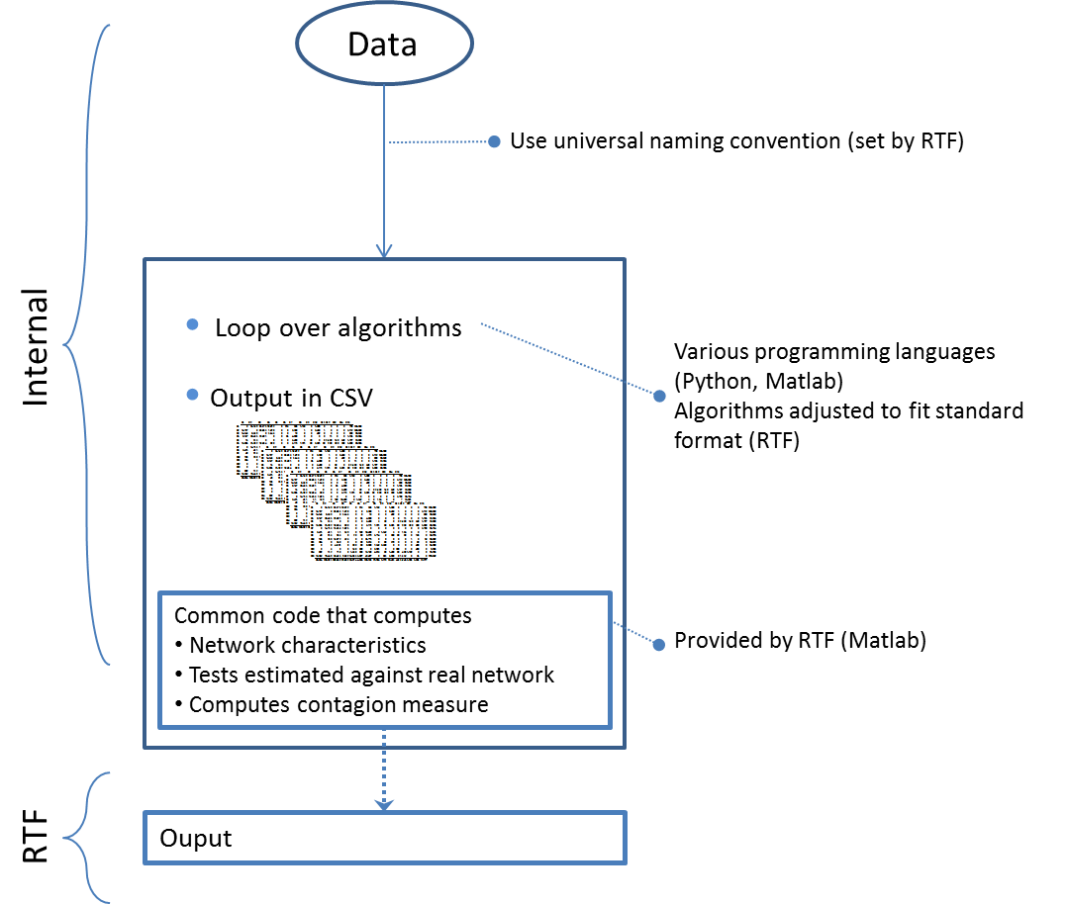

# Description of the approaches

* Xls table with contact details of contact person

# Providing the computer code

* Dropbox with the following file folder structure
* Explanation of how code works in Horse.m and each of the underlying pieces of code
* Access will be on request to keep track of dissemination

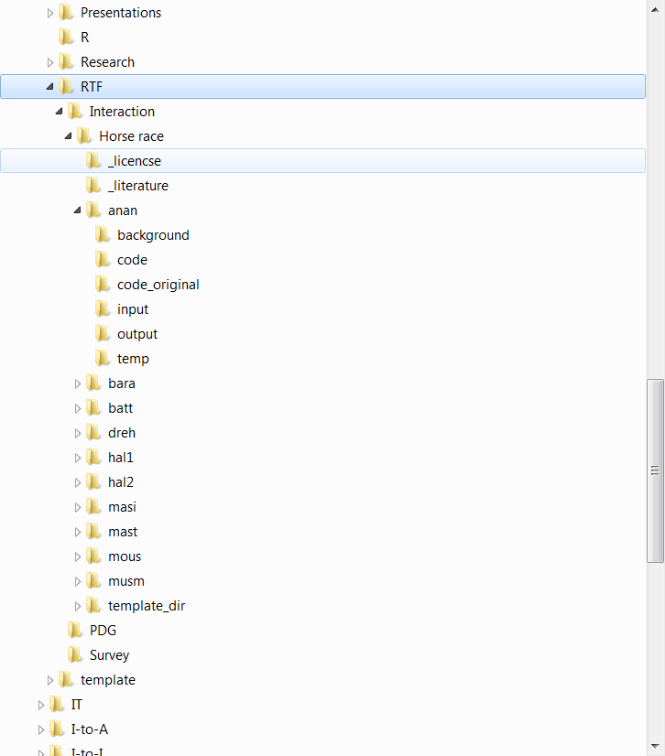

# RTF LST Network members

Iman van Lelyveld (chair) iman.van.lelyveld@dnb.nl

Dilyara Salakhova dilyara.salakhova@banque-france.fr

Grzegorz Halaj [Grzegorz.Halaj@ecb.int](mailto:Grzegorz.Halaj@ecb.int)

Hwayun Lee [hwayunlee@bok.or.kr](mailto:hwayunlee@bok.or.kr)

Ib Hansen [IBH@nationalbanken.dk](mailto:IBH@nationalbanken.dk)

Kartik Anand [kanand@bank-banque-canada.ca](mailto:kanand@bank-banque-canada.ca)

Pohl Michael [Michael.Pohl@finma.ch](mailto:Michael.Pohl@finma.ch)

Serafin Martinez Jaramillo smartin@banxico.org.mx

Sergio Souza [Sergio.souza@bcb.gov.br](mailto:Sergio.souza@bcb.gov.br)

==============================================

Matlab Horse.m file

* We assume a folder as in Graph XX of the *Horse Race.doc*
* This Horse.m file should be kept in the Horse Race ‘root’ and it will call on each of the underlying codes in the sub folders

% Choose data set and approaches to run

% ------------------------------------------

Local inputfilename “NLmatrix”

Local approachesList “anan bara batt dreh hal1 hal2 masi mast mous musm”

% Set directory paths

% ------------------------------------------

Local p_fullmatrix “_fullmatrix”

foreach approach of local approachesList {

Local p_` approach’_code “….”

Local p_` approach’_input “….”

Local p_` approach’_output “….”

Local p_` approach’_temp “….”

}

% Prepare the input files

% ------------------------------------------

% Read in the full information matrix

% We assume that the matrix is in a tab delineated CSV file with banks assets in columns and its liabilities in rows. The marginal are thus a row vector for banks’ assets and a column vector for liabilities.

Load p_fullmatrix\`inputfilename’

Matrix define M_fullInfo

% Derive descriptive information

Dimension of matrix `inputfilename’

Matrix define V_A == colsum

Matrix define V_L == rowsum

% Run codes

% ------------------------------------------

foreach approach of local approachesList {

% Each of these would leave behind an estimated matrix in the \` approach’\output directory

run p_` approach’_code\` approach’.m

% Given the full matrix and the estimated matrix, compute network measures

run computeNetworkStats

}

% Output

% ------------------------------------------

% Combine all the output and combine to a single log file / matrix outcomes

foreach approach of local approachesList {

% read in measures

% combine measures

}